**Blue Monkey Tea Design Guide**

**Logo**



**Colors**

#477980     #E0D0CA #4D4A49



**Fonts**

Oswald

Title

Subtitle

Heading 1

Heading 2

Heading 3

Heading 4

Body Text

* Bulleted List

First Time Navigation

The redesign of the website for Blue Monkey Tea Pittsburgh is intended to give first-time users a simple, yet also appealing experience. In contrast to the cluttered and text-heavy appearance of the original website’s homepage, the redesigned homepage contains very little content and mainly serves as a welcome screen. A few pictures are also included to introduce first-time customers to the physical appearance of the shop and its offerings. The bright red and orange colors of the original site are replaced with a variation of blue to emphasize the Blue Monkey brand. A navigation bar located at the top of the screen allows users to quickly see all the pages of the website right in front of them. This helps them quickly understand where everything might be located. It should be a large improvement from the long navigation sidebar of the original website that requires customers to scroll in order to see all the pages and locate the one they are looking for. Contents of every page in the new website strictly relate to the page title to prevent information overlaps. The use of accordions, tabs, and lightboxes also reduce the complexity of the website by decreasing the number of pages customers need to navigate through. All this together helps give a simple and straight-forward experience for first-time users.

Information Architecture

Everything in the redesigned website is organized across six individual pages: Home, About, Products, FAQ, Contact Us, and Stay Connected. As the Home page mainly serves as a welcome screen, most of the information is stored within the other five pages.

The About page contains the most text-heavy information. It has an accordion with sections on the shop’s mission, founder, and history. The mission section gives an overview of the Blue Monkey Tea shop and shows a video interview of the shop owner. The founder section introduces the background of the owner, Margaret Harris. The history section lists out important events in time since the founding of the shop. The Products page lists out some teas and coffees from the original website. A tabbed structure is used to organize the black teas, oolong teas, green teas, chai teas, and coffee. Within each tab, pictures of the products, along with their names and prices are displayed within a table. Each picture can be clicked and opened as a lightbox for a description of the product. The FAQ page lists a few questions about how to brew tea, how much loose-leaf to use, how long to steep the leaves, and how much tea the leaves will make. A video demonstration from Margaret Harris is embedded. The Contact Us page contains the basic store information such as locations, hours, phone number, email, and the previous website address. There is also an embedded map to show the current Squirrel Hill location and an interactive chart of the customer traffic throughout the week. The Stay Connected page simply has a form for the customer to sign up for the Blue Monkey Tea mailing list. It requires a name and email input, but also asks for some optional input. Social media links are included as picture icons at the bottom of every page.

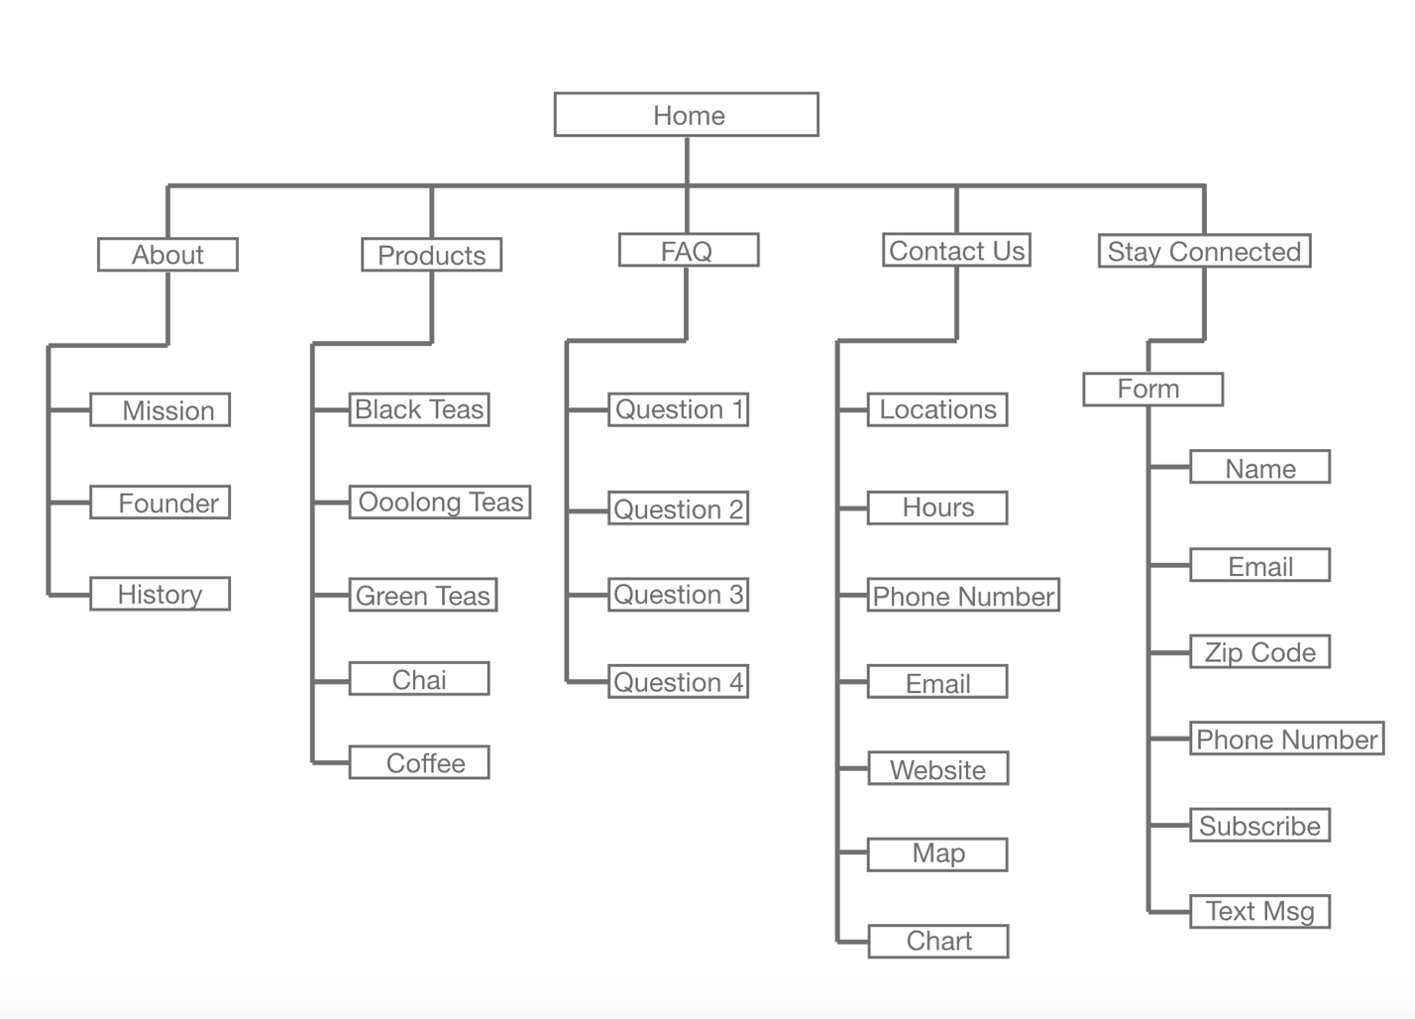Site Map